Enter database & and show tables (AnimalTracker)

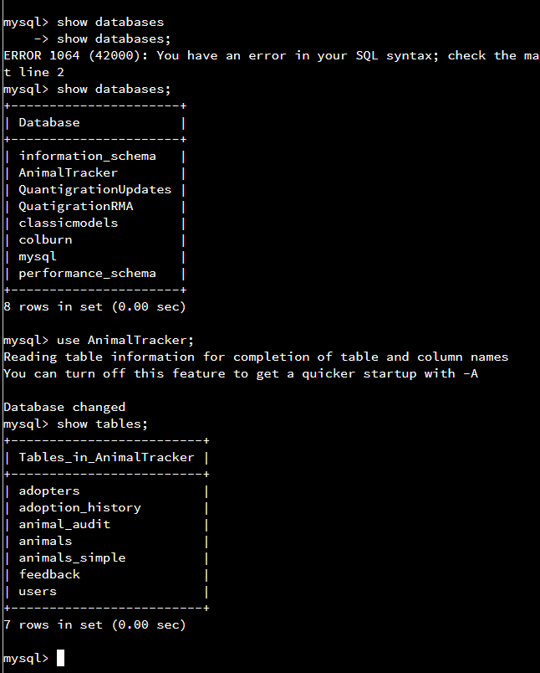

To show all the data in the animals_simple table:

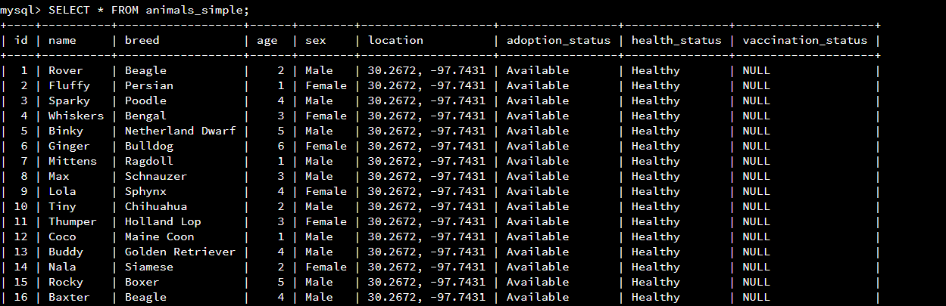

Filter for Animals Not Available for Adoption

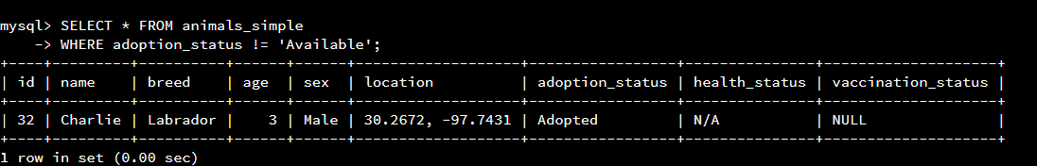

To display the feedback stored in the feedback table:

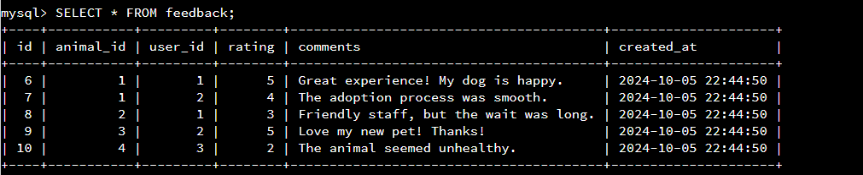

To filter feedback based on ratings, for example, to show only feedback with a rating of 4 or higher:

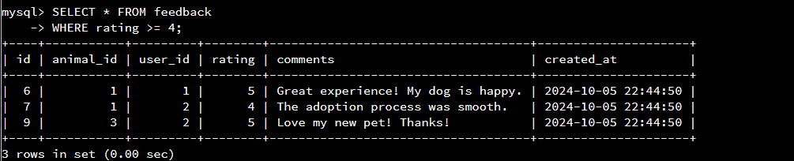

See the audit log being populated after making an update to an animal's status, first run this update query:

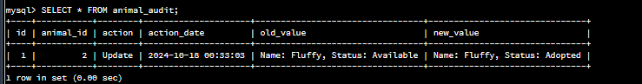

Information for Animal to be put into system

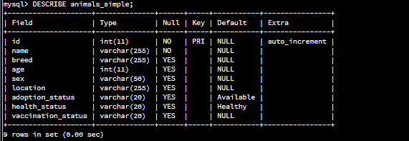

Filter Animals by age

